**Matlab Differential equation**

**Anusha Garg**

**RA21110470232**

**Question 1.** syms s(t) f(x,y)

Both s and f are abstract symbolic functions. They do not have symbolic expressions assigned to them, so the bodies of these functions are s(t) and f(x,y), respectively.

Specify the following formula for f.

( Script file )

syms s(t) f(x,y)

f(x,y) = x + 5*x*y

s(t) = t*2

Evaluating the symbolic functions:

Compute the function value at the point x = 3 and y = 4 and t = 7

f(3,4) and s(7)

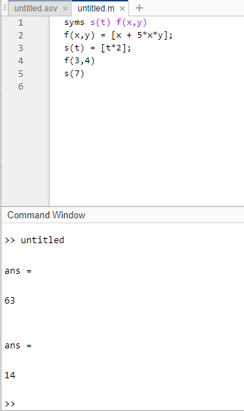

Question 2.

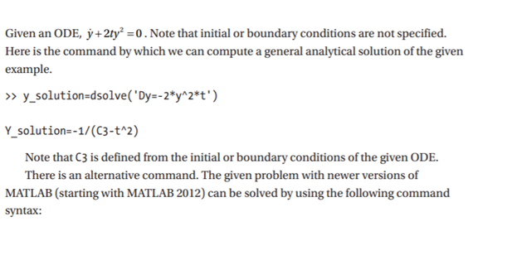

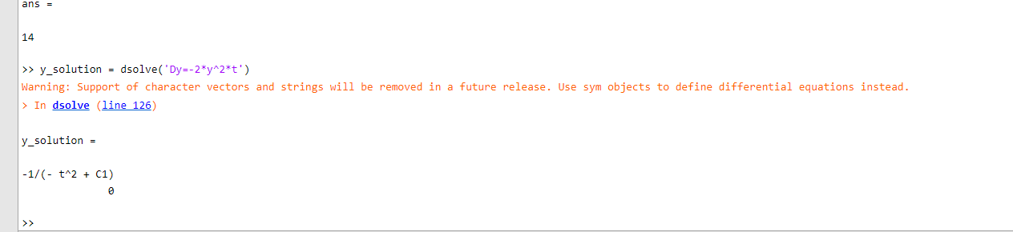

Question 3.

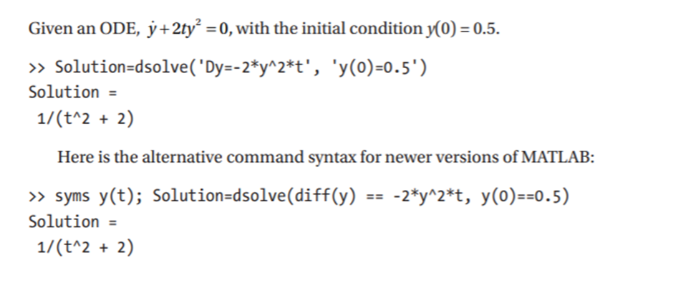

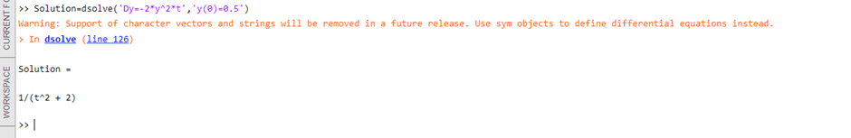

Question 4.

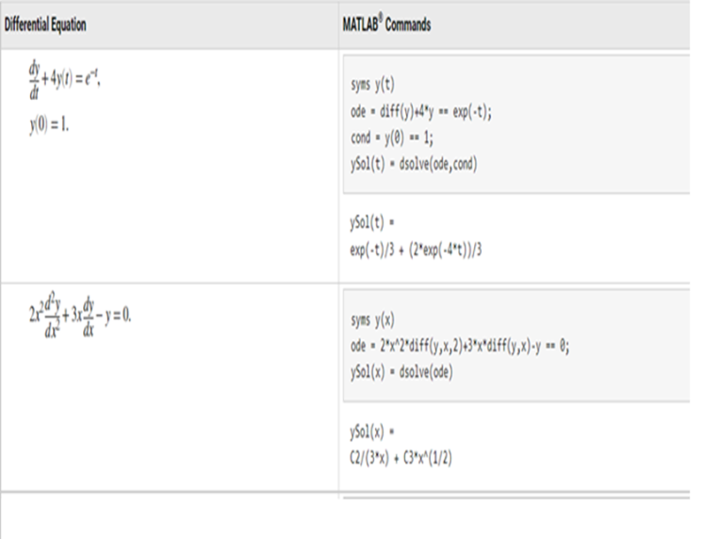

Solution 4. 1.

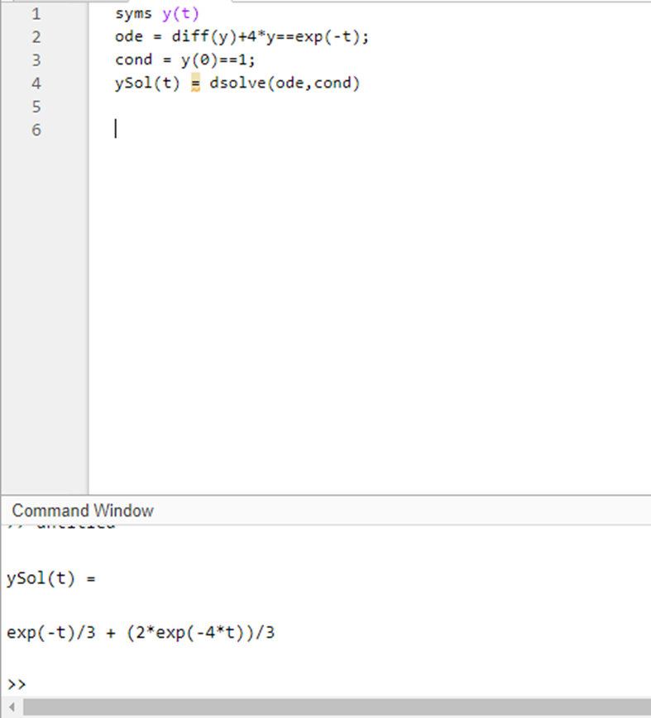

2.

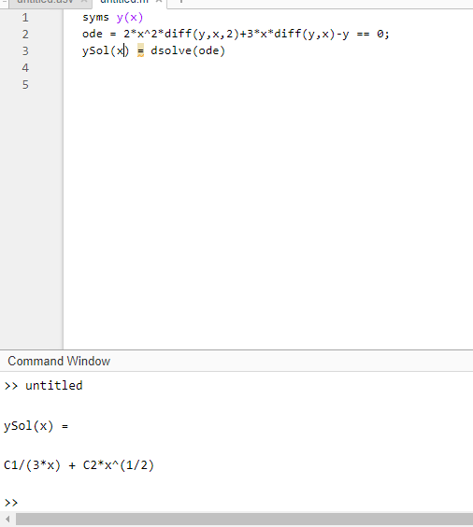

Question 5. Tryout the above for the function : cos(4x^2) – 2*y

Question 6. Try the following for y ’ = 4t^2.

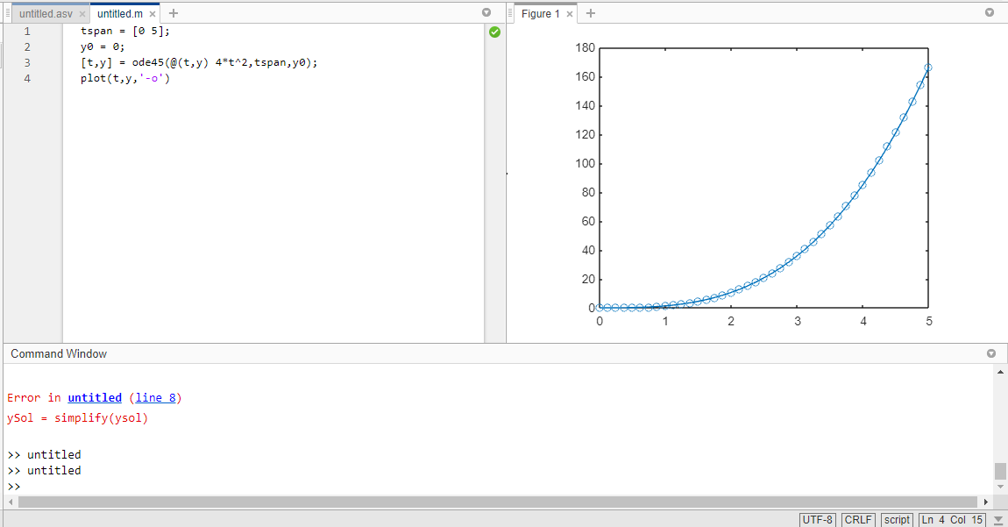

Qu

Q